**DEPARTMENT OF ADVANCED SCIENCE AND TECHNOLOGY**

**UNIVERSITY OF COMPUTER STUDIES (MYEIK)**

**2023-2024 ACADEMIC YEAR**

**CST-2223 INTRODUCTION TO SOFTWARE ENGINEERING**

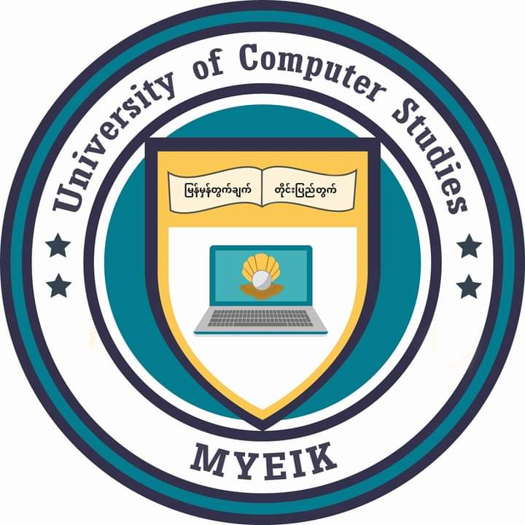

**INTRODUCTION TO SOFTWARE ENGINEERING PROJECT**

**JEWELRY PALACE**

**SUBMITTED BY:**

KPTMYK-001253 Mg Aung Thura Kyaw

KPTMYK-001368 Mg Kyaw Soe Win

KPTMYK-001376 Mg Nanda Tun

KPTMYK-001370 Ma May Thet Paing

KPTMYK-001378 Ma Kay Thazin Phoo

KPTMYK-001352 Ma Hsu Moe Yu San

**September, 2024 Second Year (B.C.Sc./ B.C.Tech.)**